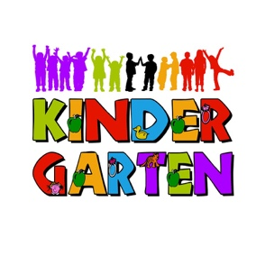
Preschool Skills Checklist
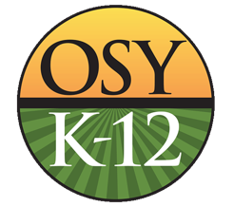

Child’s Name: _______________________________________________

The bolded skills are the most important to have in preparation for Kindergarten. Please put a mark in the box next to each of the child’s accomplishments:
- Can say his/her complete name
- Can write name, using a capital letter for the first letter
- Knows all the letter names
- Knows 10 or more letter sounds/syllables
- Can identify the first sound in a word
- Can identify the numbers 0-10
- Can count out loud to 20
- Can follow 1- or 2-step directions (for example: “Please pick up your shoes and put them in the closet.”)
- Listens attentively for 10 minutes (for example: when you are reading to them)
- Takes turns and shares toys
- Verbally states feelings (for example: “I feel . . .”)
- Can go to the bathroom alone
- Is able to snap, button, and/or zip pants and/or shirt

- Knows cheers, chants, or songs
- Recognizes the letters in name
- Can tell a story in sequence: beginning, middle, and end
- Can follow words left to right, top to bottom, page to page
- Can draw a self-portrait that includes: head, eyes, nose, and mouth
- Can break words into syllables
- Can retell a story or event

- Knows geometric shapes (for example): (circle); (triangle); (square); (rectangle)
- Recognizes and says 9 colors (yellow, red, blue, green, orange, purple, black, white, brown)
- Can sort items by color, shape, or size (for example: sort small marbles from the large marbles)
- Can point to and count ten items out loud
- Offers simple, age-appropriate reasons and ideas for tasks and problem solving (for example: What to do if there are 2 paint stations and 3 people who want to paint?)
- Asks and answers questions
- Acknowledges or responds nonverbally to common words or phrases such as “hello, goodbye, snack time, or backroom”, when accompanied by adult gestures
- Greets others (“Hello, my name is ____; high-five; handshake)
- Knows how to line up
- Verbalizes needs (for example: “I need water.” “I am hungry.”)
- Comfortable asking adults for help
- Walks quietly in a straight line.
- Understands rules and can follow them
- Writes using correct pencil grip
- Demonstrates correct scissor grip
- Can hop
- Can march
- Can run
- Can jump
- Can skip
- Can stack 5 or more objects
- Can cut on a line. _____

